Unit 2 – Lesson 2. Creating an Image Gallery App
Aim:
How do we build an Image Gallery App?

Objectives: After the lesson, students will be able to:
- Obtain understanding of ImageView and @drawable folder
- Understand Gallery View and BaseAdapter class

CLASS PROCEDURE:

Do Now:
Open Android Studio, and create a new app project. Name your project “GalleryView”. Then find seven images online, save those pictures in .jpg format by using Paint or Photoshop. Then upload all of the images into the app > res > drawable > folder. You can simply copy the image files and then click on “drawable” and choose “paste” to upload the images.

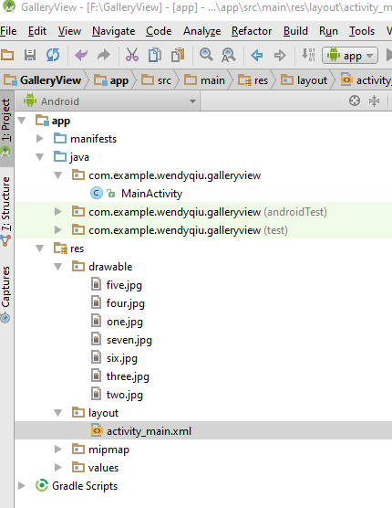

Class Discussion / Presentation:

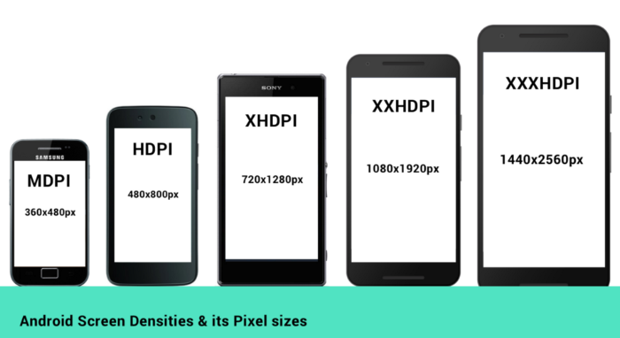

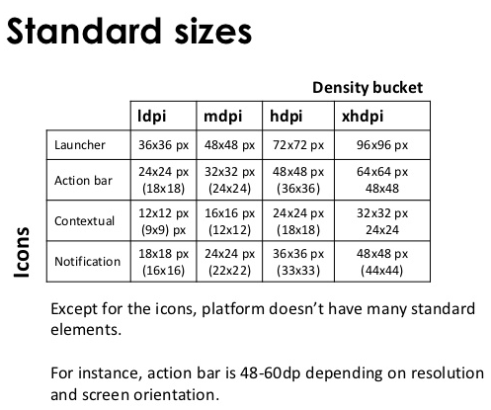

Lab / Pair – sharing Activity:
Work with your partner and complete the GalleryView app!

- In ActivityMain.java, declare an object Gallery, an Integer[] array to save the GalleryImageList R.id, and an object ImageView:

Gallery Imagegallery;
Integer[] GalleryImagesList =
{
R.drawable.one,
R.drawable.two,
R.drawable.three,
R.drawable.four,
R.drawable.five,
R.drawable.six,
R.drawable.seven
};
ImageView imgGalleryImage;

- We then need to instantiate the objects and link the objects to the UI in the onCreate(). To display a big image when the smaller image icon is clicked, we use a class ImageAdapter class that will be specified later. We need to instantiate it in the onCreate(). Here’s the onCreate() method:

protected void onCreate(Bundle savedInstanceState)
{
super.onCreate(savedInstanceState);
setContentView(R.layout.activity_main);
imgGalleryImage = (ImageView)findViewById(R.id.imgGalleryImage);
imgGalleryImage.setImageResource(R.drawable.one);
Imagegallery = (Gallery)findViewById(R.id.gallery);
Imagegallery.setAdapter(new ImageAdapter(this));
Imagegallery.setOnItemClickListener(new OnItemClickListener()
{
@Override
public void onItemClick(AdapterView<?> parent, View view,
int position, long id)
{
imgGalleryImage.setImageResource(GalleryImagesList[position]);
}
});
}
- Finally, we need to write the ImageAdapter class. The ImageAdapter class extends a BaseAdapter class provided by Android. The purpose is to allow the user to slide, pick a smaller image icon on the top and then display it as a big image on screen. We need to getCount() and getItem() and getItemId() before we return the View.

private class ImageAdapter extends BaseAdapter
{
Context context;
public ImageAdapter(Context context)
{
this.context = context;
}
@Override
public int getCount()
{
return GalleryImagesList.length;
}
@Override
public Object getItem(int position)
{
return GalleryImagesList[position];
}
@Override
public long getItemId(int position)
{
return position;
}
@Override
public View getView(int position, View convertView, ViewGroup parent)
{
ImageView imageView = new ImageView(this.context);
imageView.setImageResource(GalleryImagesList[position]);
imageView.setLayoutParams(new Gallery.LayoutParams(150, 200));
imageView.setScaleType(ScaleType.FIT_XY);
return imageView;
}}
- Don’t forget to set the Gallery and the ImageView in the activity_main.xml! Here’s an example of the finished app:

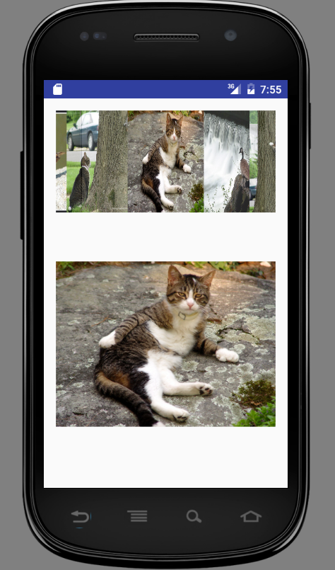

Sample Solution:

activity_main.xml:

<?xml version="1.0" encoding="utf-8"?>
<LinearLayout xmlns:android="http://schemas.android.com/apk/res/android"
xmlns:tools="http://schemas.android.com/tools"
android:layout_width="match_parent"
android:layout_height="match_parent"
android:paddingBottom="@dimen/activity_vertical_margin"
android:paddingLeft="@dimen/activity_horizontal_margin"
android:paddingRight="@dimen/activity_horizontal_margin"
android:paddingTop="@dimen/activity_vertical_margin"
tools:context="com.example.wendyqiu.galleryview.MainActivity"
android:orientation="vertical" >
<Gallery
android:id="@+id/gallery"
android:layout_width="fill_parent"
android:layout_height="wrap_content"/>
<ImageView
android:id="@+id/imgGalleryImage"
android:layout_width="fill_parent"
android:layout_height="fill_parent"/>
</LinearLayout>

MainActivyt.java:

package com.example.wendyqiu.galleryview;
import android.support.v7.app.AppCompatActivity;
import android.os.Bundle;
import android.app.Activity;
import android.content.Context;
import android.os.Bundle;
import android.view.View;
import android.view.ViewGroup;
import android.widget.AdapterView;
import android.widget.BaseAdapter;
import android.widget.Gallery;
import android.widget.ImageView;
import android.widget.AdapterView.OnItemClickListener;
import android.widget.ImageView.ScaleType;
public class MainActivity extends Activity {
@SuppressWarnings("deprecation")
Gallery Imagegallery;
Integer[] GalleryImagesList =
{
R.drawable.one,
R.drawable.two,
R.drawable.three,
R.drawable.four,
R.drawable.five,
R.drawable.six,
R.drawable.seven
};
ImageView imgGalleryImage;
@Override
protected void onCreate(Bundle savedInstanceState)
{
super.onCreate(savedInstanceState);
setContentView(R.layout.activity_main);
imgGalleryImage = (ImageView)findViewById(R.id.imgGalleryImage);
imgGalleryImage.setImageResource(R.drawable.one);
Imagegallery = (Gallery)findViewById(R.id.gallery);
Imagegallery.setAdapter(new ImageAdapter(this));
Imagegallery.setOnItemClickListener(new OnItemClickListener()
{
@Override
public void onItemClick(AdapterView<?> parent, View view,
int position, long id)
{
imgGalleryImage.setImageResource(GalleryImagesList[position]);
}
});
}
private class ImageAdapter extends BaseAdapter
{
Context context;
public ImageAdapter(Context context)
{
this.context = context;
}
@Override
public int getCount()
{
return GalleryImagesList.length;
}
@Override
public Object getItem(int position)
{
return GalleryImagesList[position];
}
@Override
public long getItemId(int position)
{
return position;
}
@Override
public View getView(int position, View convertView, ViewGroup parent)
{
ImageView imageView = new ImageView(this.context);
imageView.setImageResource(GalleryImagesList[position]);
imageView.setLayoutParams(new Gallery.LayoutParams(150, 200));
imageView.setScaleType(ScaleType.FIT_XY);
return imageView;
}
}
}

HW: Complete the Gallery app.

